Southwest Harbor Police Department 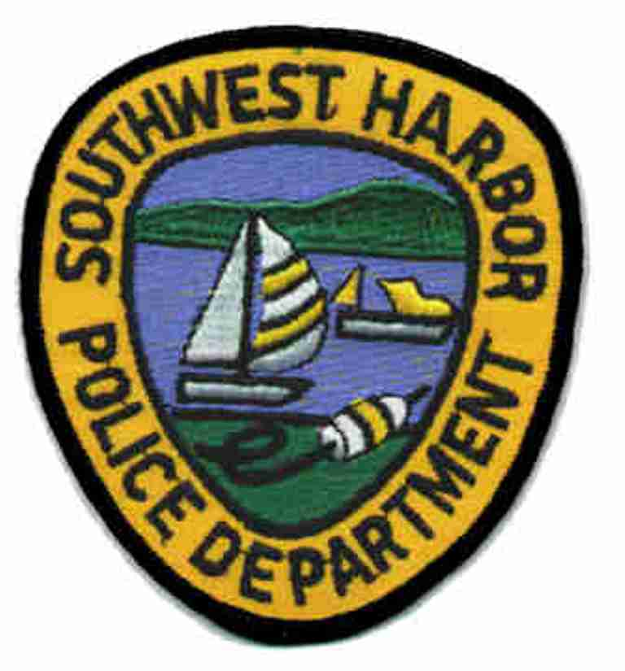
David Chapais – Chief of Police P.O. Box 1048 • 26 Village Green Way • Southwest Harbor, ME. 04679
Business: 207-244-7911
Fax: 207-244-5552

"Good Morning Project"

The Southwest Harbor Police Department is pleased to sponsor the "Good Morning Project".
This program is designed to assist Southwest Harbor senior citizens or adults with disabilities living alone in the community. The goal is to assist these people so that they can continue living an independent lifestyle.
"Good Morning Project" will aid in eliminating many concerns that families may have about loved ones that live alone. The program provides the security of knowing that the family member will have a source of daily contact. This program is free.

Upon completing an application and upon its approval, a dispatcher or police officer from the Southwest Harbor Police Department will call daily, between 8 AM and 10 AM, to say "good morning". If contact cannot be made by telephone, a police officer will come to check the welfare of the participant.

ABOUT THE PROGRAM

Who is eligible?

Any Southwest Harbor residents may be eligible for this program if they are a senior citizen
who is 60 or older and are living alone or an adult with disability living alone. A short application
must be completed and a waiver signed. This will provide us with some basic information about the
participant.

Is there any charge for this program?

No. This program is a free service provided by the Southwest Harbor Police Department.

How can I participate in this program?

Call or stop by the Southwest Harbor Police Department and complete an application.

What if I have a Lifeline?

This program compliments Lifeline or any other service you may already participate in. Lifeline
and these other services trigger immediate assistance in an emergency.

Are you interested?

If you are interested in this program, or know someone who might benefit from the
"Good Morning Project" program, please contact us.

1of 4
03/2013-lrh/dc
Office use only
Participant Number:_________

"Good Morning Project"
Participant Application Form
(please print clearly)

Date: _______________

Name: ________________________________________________________________________________

Mailing Address: ______________________________________________________________________

Physical Address: ______________________________________________________________________

Telephone: _______________________________ I Live Alone: ◻ YES ◻ NO

Contact person/s who lives nearby:

Name: ________________________________________ Telephone: ____________________________

Address: ______________________________________________________________________________

Person/s to notify in an emergency:

Name: ________________________________________ Telephone: ____________________________

Address: ______________________________________________________________________________

Primary Care Physician: _______________________________ Telephone: _____________________

Medical Conditions the "Good Morning Project" caller should be aware of:

1. _________________________________________________________________________________

2. _________________________________________________________________________________

3. _________________________________________________________________________________

4. _________________________________________________________________________________

Preferred call time: ◻ 8:00 ◻ 8:15 ◻ 8:30 ◻ 8:45
(please check one) ◻ 9:00 ◻ 9:15 ◻ 9:30 ◻ 9:45

2 of 4
03/2013-lrh/dc

THE FOLLOWING INFORMATION WILL BE KEPT CONFIDENTIAL
(PLEASE PRINT CLEARLY)

Medications you take on a regular basis (both prescription and non-prescription) and dosages:

1. _________________________________________________________________________________

2. _________________________________________________________________________________

3. _________________________________________________________________________________

4. _________________________________________________________________________________

5. _________________________________________________________________________________

6. _________________________________________________________________________________

Medication Allergies: ___________________________________________________________________

Do you have a "DNR" (do not resuscitate), Living Will or Advanced Directive? ◻ YES ◻ NO

If yes, please explain: ___________________________________________________________________
______________________________________________________________________________________

Do you have a hidden key? ◻ YES ◻ NO

Location: _____________________________________________________________________________

Do you drive a car? ◻ YES ◻ NO

Description of you car: __________________________________________________________________

License plate number: ________________________________

Date: ________________________

Person filling out this form: ______________________________________________________________

Participant's Name Printed: ______________________________________________________________

Participant's (or authorized representative) Signature: ________________________________________

3 of 4
03/2013-lrh/dc

THIS INFORMATION WILL BE KEPT CONFIDENTIAL
(PLEASE PRINT CLEARLY)

I, ________________________________________, ◻ DO ◻ DO NOT authorize the Southwest Harbor Police Department "Good Morning Project" program coordinator, or his/her authorized designee, to receive pertinent information about myself from my family or primary care physician as it may pertain to my well-being.

I, ________________________________________, ◻ DO ◻ DO NOT authorize the "Good Morning Project" program coordinator to inform the Southwest Harbor Police Department of my participation in the program and authorize the police to use "forcible entry" if needed to access my house/apartment/mobile home.

This will absolve the Town of Southwest Harbor and the "Good Morning Project" program of any and all liability for receiving information pertaining to my general well being and safety. It will also absolve the Southwest Harbor Police Department of any and all property damage that may occur if they are unable to make contact with me and must force entry into my residence. It will also absolve the Town of Southwest Harbor and the "Good Morning Project" program of any and all liability for any scheduled calls that were not made do to circumstances beyond their control.

Date: ________________________

Signature: ____________________________________________

Witness: _____________________________________________

4 of 4
03/2013-lrh/dc

